**BE Fourth Year Computer Engineering**

**PROJECT SYNOPSIS**

**ON**

**Elevating Patient Care: Precision Knee Osteoarthritis Diagnosis with CNN**

**Submitted by**

**Nikita Lavhaji Pingale (B190814201)**

**Pradip Suresh Irkar (B190814242)**

**Priya Anil Kumar Maurya (B190814267)**

**Guided by**

**Prof. Shobha Bamane**



**B.E. (Comp)- 2023-24**

## DEPARTMENT OF COMPUTER ENGINEERING

**ISB&M COLLEGE OF ENGINEERING, NANDE, PUNE**

**UNIVERSITY OF PUNE**

**2023-24**

**Abstract**

Knee osteoarthritis (OA) stands as a global behemoth, silently affecting countless lives and challenging healthcare's frontiers. Precise diagnosis and meticulous severity classification have become the heralds of enlightened clinical care. In this expedition, we set sail on the uncharted waters of medical innovation, navigating by the starlight of Convolutional Neural Networks (CNNs), determined to redefine knee OA's map. Our voyage unfurls with a diverse gallery of knee X-ray images, each a testament to the human experience. We present a pioneering CNN-driven approach, which unveils the intricate tapestry of knee OA and categorizes it into distinctive severity levels. As we venture deeper, our research dissects the CNN's architecture, wields the tools of data preprocessing with artistic finesse, and unearths results that echo the promise of avant-garde technology in sculpting the musculoskeletal landscape. Our contribution marks a shift in the very constellation of knee OA diagnosis—a metamorphosis of precision, efficiency, and a resolute commitment to patient-centric healthcare.

**Introduction**

In the vast tapestry of global health, knee osteoarthritis (OA) emerges as a pervasive yet silently unfolding affliction, touching the lives of millions with an often-unnoticed weight. Beyond the realm of discomfort and mobility restrictions, this musculoskeletal enigma casts a long, looming shadow into the heart of public health. Within this ever-evolving landscape, where the artistry of medicine converges with the cutting-edge canvas of technology, we embark on a transformative odyssey. In this age of digitized healthcare, we harness the dynamic potential of Convolutional Neural Networks (CNNs) to breathe vitality into the age-old challenge of knee OA diagnosis. Infused with inspiration from the artistry of convolution and the science of neural networks, our journey unfolds through the intricate terrain of knee OA, endeavouring to revolutionize both its diagnosis and the classification of its multifaceted severity.

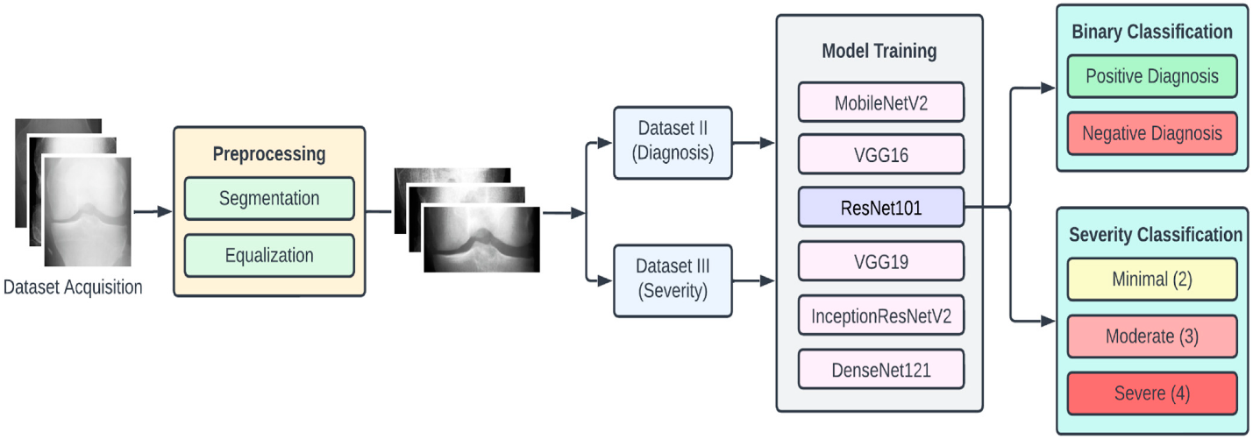

Fig. KOA Detection and Severity Classification using CNN

Our voyage commences with a seemingly modest knee X-ray image, each one a silent witness to the mysteries of this musculoskeletal conundrum. Within these pages, we unveil an innovative approach that entrusts CNNs with the task of illuminating the nuanced intricacies of knee OA. The result? A categorical classification that breathes life into the subtle gradations of severity. Our exploration takes us deep into the architecture of the CNN, guiding us through the artistry of data preprocessing, ultimately revealing results that underscore the transformative potential of this cutting-edge technology within the realm of musculoskeletal health. As we navigate this innovative landscape, our ultimate ambition is to orchestrate a paradigm shift within the sphere of knee OA diagnosis. Our pursuit endeavours to transcend the mere enhancement of precision and efficiency, extending into the very heart of healthcare—the welfare and solace of the patient. Within the pages that follow, we extend our invitation, beckoning you to join us on this transformative journey. This journey promises not merely to revolutionize knee OA diagnosis but to forever reshape the lens through which we perceive and address this widespread and intricate musculoskeletal challenge.

**Literature Review**

|  |  |  |  |
| --- | --- | --- | --- |
| **Roll No** | **Paper Name** | **Author** | **Abstract** |
| **1** | **Discriminative Regularized Auto-Encoder for Early Detection of Knee OsteoArthritis: Data from the Osteoarthritis Initiative** | **Yassine Nasser, Rachid Jennane** | **OsteoArthritis (OA) is the most common disorder of the musculoskeletalsystem and the major cause of reduced mobility among seniors. The visual evaluation of OA still suffers from subjectivity. Recently, ComputerAided Diagnosis (CAD) systems based on learning methods showed potential for improving knee OA diagnostic accuracy.** |

|  |  |  |  |
| --- | --- | --- | --- |
| **Roll No** | **Paper Name** | **Author** | **Abstract** |
| **1** | **Discriminative Regularized Auto-Encoder for Early Detection of Knee OsteoArthritis: Data from the Osteoarthritis Initiative** | **Yassine Nasser, Rachid Jennane** | **OsteoArthritis (OA) is the most common disorder of the musculoskeletalsystem and the major cause of reduced mobility among seniors. The visual evaluation of OA still suffers from subjectivity. Recently, ComputerAided Diagnosis (CAD) systems based on learning methods showed potential for improving knee OA diagnostic accuracy.** |

|  |  |  |  |
| --- | --- | --- | --- |
| **Roll No** | **Paper Name** | **Author** | **Abstract** |
| **1** | **Discriminative Regularized Auto-Encoder for Early Detection of Knee OsteoArthritis: Data from the Osteoarthritis Initiative** | **Yassine Nasser , Rachid Jennane** | **OsteoArthritis (OA) is the most common disorder of the musculoskeletalsystem and the major cause of reduced mobility among seniors. The visual evaluation of OA still suffers from subjectivity. Recently, ComputerAided Diagnosis (CAD) systems based on learning methods showed potential for improving knee OA diagnostic accuracy.** |

|  |  |  |  |
| --- | --- | --- | --- |
| **Roll No** | **Paper Name** | **Author** | **Abstract** |
| **1** | **Discriminative Regularized Auto-Encoder for Early Detection of Knee OsteoArthritis: Data from the Osteoarthritis Initiative** | **Yassine Nasser , Rachid Jennane** | **OsteoArthritis (OA) is the most common disorder of the musculoskeletalsystem and the major cause of reduced mobility among seniors. The visual evaluation of OA still suffers from subjectivity. Recently, ComputerAided Diagnosis (CAD) systems based on learning methods showed potential for improving knee OA diagnostic accuracy.** |

**Project Objective**

The objective of this study is to develop and implement a Convolutional Neural Network (CNN) for the automated detection of knee osteoarthritis in X-ray images. Furthermore, the research aims to extend the capabilities of the CNN to classify the severity of osteoarthritis, providing a comprehensive diagnostic tool. The study seeks to achieve high accuracy in distinguishing between healthy knees and those with osteoarthritis, while also categorizing the severity of the condition. Through the utilization of advanced deep learning techniques, this research aspires to contribute to the early and accurate diagnosis of knee osteoarthritis, potentially enhancing clinical decision-making processes and improving patient outcomes.

**Conclusion**

This research work addressed the identification and classification of knee osteoarthritis (KOA), which is one of the most challenging medical conditions in old-aged people. The efforts were directed toward proposing, implementing, and testing an automated, fast, and accurate methodology that can help reduce the manual efforts of the physician and decrease the amount of false diagnosis cases. For this purpose, we used the prediction capabilities of deep neural network. In conclusion, the development of a Convolutional Neural Network (CNN)-based diagnostic tool for knee osteoarthritis holds immense potential to transform the landscape of musculoskeletal healthcare. The outlined scope, rationale, and working modules demonstrate the multifaceted advantages and applications that such a tool can bring to clinical practice, research, and patient outcomes. By automating the diagnosis of knee osteoarthritis, this technology addresses the critical need for early detection, providing healthcare professionals with a reliable, efficient, and consistent means of identifying the condition. The advantages encompass improved accuracy, streamlined workflows, and personalized treatment plans, ultimately contributing to enhanced patient care.

**References**

[1] Health Organization, Geneva, Switzerland. (Jun. 2019). Chronic Rheumatic Conditions. [Online]. Available: https://www.who. int/chp/topics/rheumatic/en/

[2] M. Cross et al., “The global burden of hip and knee osteoarthritis: Estimates from the global burden of disease 2010 study,” Ann. Rheumatic Diseases, vol. 73, no. 7, pp. 1323– 1330, Jul. 2014.

[3] K. Lim and C. S. Lau, “Perception is everything: OA is exciting,” Int. J. Rheumatic Diseases, vol. 14, no. 2, pp. 111–112, May 2011.

[4] B. Heidari, “Knee osteoarthritis prevalence, risk factors, pathogenesis and features: Part I,” Caspian J. Internal Med., vol. 2, no. 2, p. 205, 2011.

[5] J. Kellgren and J. Lawrence, “Radiological assessment of osteoarthrosis,” Ann. Rheumatic Diseases, vol. 16, no. 4, p. 494, 1957.

[6] L. Shamir et al., “Knee X-ray image analysis method for automated detection of osteoarthritis,” IEEE Trans. Biomed. Eng., vol. 56, no. 2, pp. 407–415, Feb. 2009

**Date:**

**Guide Project Coordinator Head**

**(Prof. ) (Prof. ) Dept. of Computer Engineering**